Proposal

Special Project Open Evolve - Proposal
[Authors' Names, Affiliations, and Contact Information Here]

RE: Major Sean Allen, SDA TAP Lab Representatives

1. Introduction
This proposal outlines the development and implementation plan for "Open Evolve," a special project aimed at advancing automated algorithm discovery and code optimization. This document is submitted for review and approval on July 25, 2025.

2. UCT Processing - Overview
To keep pace with adversary advances, we must make a modest investment of time and capital in automated benchmarking. Uncorrelated Track (UCT) processing underpins timely and accurate orbit estimation, a critical step in detecting, correlating, and responding to potential threats in Space Domain Awareness. Adversaries exploit CCDM to degrade sensor data quality, leaving traditional algorithms unable to reconcile sparse and/or noisy observations into reliable orbital estimates. Today’s development cycles are locked in manual trial‑and‑error and fragmented expertise. Special Project Open Evolve, a derivative of Google DeepMind’s AlphaEvolve framework, could automate the discovery, optimization, and evaluation of UCT processing algorithms through evolutionary search and LLM‑driven code mutations, running broad parallel experiments against clear performance metrics. This special project will test and validate the Open Evolve framework’s applicability to processing UCTs, determining its operational feasibility, and delivering either an enhanced UCT processing algorithm or a clear roadmap for implementing the architecture.

3. Open Evolve - Overview
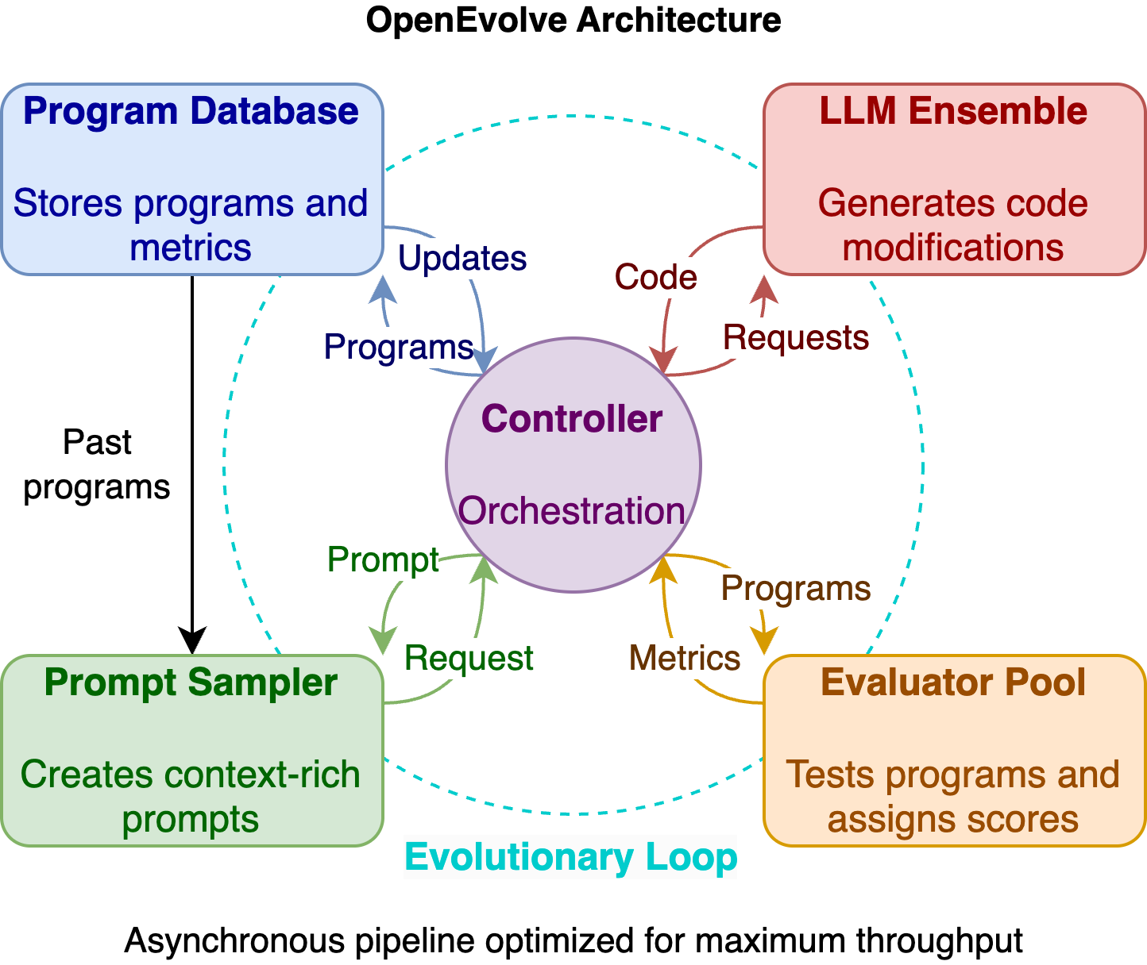
OpenEvolve is an open‑source adaptation of Google DeepMind’s AlphaEvolve agent that automates algorithm discovery and code optimization by leveraging large language models to iteratively generate and refine code. A distributed controller loop coordinates multiple LLM instances, evaluation pipelines, and a program database, while multi‑objective methods like MAP‑Elites balance performance and innovation. By integrating with any OpenAI‑compatible API (Anthropic, Gemini, or open‑source), employing deterministic seeding, checkpointing, and artifact tracking, it ensures fully reproducible experiments. Built‑in visualization tools and a command‑line interface allow researchers and engineers to monitor evolution trees, compare program versions, and manage long‑running optimization tasks at scale.

4. Project Objective
Validate the OpenEvolve framework for UCT processing by integrating it with SDA benchmarks, automating algorithm discovery and evaluation, and delivering a reproducible pipeline, custom metric, and technical report.
5. Approach
- Lightweight validation tests
  - Run existing proof‑of‑concepts on the repository’s example puzzle problems
  - Execute scaled‑down versions of problems analogous to UCT processing algorithms
- Domain‑specific integration
  - Develop a custom evaluation metric (openevolve/evaluator.py)
  - Ingest the current UCT benchmark dataset and test harness into the OpenEvolve database
  - Configure weights and deterministic seeds within the framework to control experiment “temperature”
  - Launch the end‑to‑end OpenEvolve research loop

6. Justification: Objectives, Approach & Challenges
Objectives: We aim to eliminate SDA development bottlenecks by automating cross‑discipline algorithm discovery and optimization. This removes human limits on work hours and expertise breadth, delivering continuous innovation at scale.
Approach: A 24/7 agentic system runs parallel, iterative experiments using LLM‑driven evolutionary search and code mutations. On‑demand scaling of compute resources ensures rapid, reproducible results within existing SDA pipelines.
Challenges: Balancing compute costs and resource allocation as LLM workloads grow. Integrating automated workflows without disrupting legacy processes.

7. Resources Needed:
- Human Capital:
  - AFRL/DIU Fellows for technical guidance
  - Industry specialists to refine elevator.py evaluation logic
  - Project manager to synchronize team efforts and sustain momentum
- Initial UCT Processors & Data:
  - Access to as many existing UCT Processors as possible through government resources
  - More orbital data to widen the possible test suite of the UCT Benchmark
- Compute Resources
  - Access to LLM inference (API‑based or on‑premises)
  - Budget for compute infrastructure (cloud credits or local hardware)
- Engineering Tools
  - Version control and CI/CD pipelines for reproducible experiments
  - Artifact tracking and checkpointing systems
- Time Allocation
  - Problem‑mapping phase: Define how SDA UCT tracking variables map to OpenEvolve architecture (independent vs. dependent variables)
  - Research cycle execution: Run iterative OpenEvolve experiments, analyze results, and refine configurations

8. Expected Outcomes:

3 Months

Complete validation of the repository’s known test cases

6 Months

Validate lightweight, domain‑specific problem instances

Integrate our UCT benchmarking algorithm into the OpenEvolve research architecture

12 Months

Execute sustained “trials” on UCT processing problems

Analyze and refine framework configurations for improved fit

Demonstration on if and how OpenEvolve enhanced the UCT processor (Performance Assessment)
- Final Deliverable: Deliver to stakeholders a modified algorithm/code block

9. Roles & Responsibilities (SDA TAP to provide PM/oversight)
SDA TAP Lab: Provide project management, oversight, and coordination with DIU.
AFRL/DIU Fellows: Offer technical expertise, guide evaluation metric development, support LLM integration.
Industry Specialists: Refine domain-specific evaluation logic, assist with algorithmic validation.
Project Manager: Coordinate resources, track milestones, ensure timely deliverables.
Compute Team: Provision and manage LLM inference resources and infrastructure.
Engineering Team: Set up CI/CD pipelines, version control, and artifact tracking for reproducible experiments.

10. Project Stakeholders (Sponsors / Advocates / Champions)
Early Adopters: Melrose Brown (NSW), Emma Kerr (DSTL), Di Mico (I3E / SDA TAP Lab), MIT AeroAstro / AI Accelerator, Texas A&M / UT Austin, Moriba Ja, Wussan Park, Marcus Holsinger, Jeff Choate
Late‑Stage Sponsors: Virginia Wright (DARPA / SSDP / AFRL)

11. Deliverables
- Technical Report: Technical analysis of outcomes using quantifiable metrics. Assessing: cost, time, solution quality, reproducibility, and efficiency.
- Best Program: File.py

Copy of Proposal

Special Project Open Evolve - Proposal
[Authors' Names, Affiliations, and Contact Information Here]

RE: Major Sean Allen, SDA TAP Lab Representatives

1. Introduction
This proposal outlines the development and implementation plan for "Open Evolve," a special project aimed at advancing automated algorithm discovery and code optimization. This document is submitted for review and approval on July 25, 2025.

2. UCT Processing - Overview
To keep pace with adversary advances, we must make a modest investment of time and capital in automated benchmarking. Uncorrelated Track (UCT) processing underpins timely, accurate orbit estimation, the critical step in detecting, correlating, and responding to potential threats in Space Domain Awareness. Adversaries exploit CCDM to degrade sensor data quality, leaving traditional algorithms unable to reconcile sparse, noisy observations into reliable tracks. Today’s development cycles are locked in manual trial‑and‑error and fragmented expertise. Special Project Open Evolve, a derivative of Google DeepMind’s AlphaEvolve framework, could automate the discovery, optimization, and evaluation of UCT processing algorithms through evolutionary search and LLM‑driven code mutations, running broad parallel experiments against clear performance metrics. This special project will test and validate the Open Evolve framework’s applicability to UCT processing, determining its operational feasibility and delivering either an enhanced UCT benchmarking system or a clear roadmap for implementing the architecture.

3. Open Evolve - Overview

OpenEvolve is an open‑source adaptation of Google DeepMind’s AlphaEvolve agent that automates algorithm discovery and code optimization by leveraging large language models to iteratively generate and refine code. A distributed controller loop coordinates multiple LLM instances, evaluation pipelines, and a program database, while multi‑objective methods like MAP‑Elites balance performance and innovation. By integrating with any OpenAI‑compatible API (Anthropic, Gemini, or open‑source), employing deterministic seeding, checkpointing, and artifact tracking, it ensures fully reproducible experiments. Built‑in visualization tools and a command‑line interface allow researchers and engineers to monitor evolution trees, compare program versions, and manage long‑running optimization tasks at scale.

4. Project Objective
Validate the OpenEvolve framework for UCT processing by integrating it with SDA benchmarks, automating algorithm discovery and evaluation, and delivering a reproducible pipeline, custom metric, and technical report.
5. Approach
- Lightweight validation tests
  - Run existing proof‑of‑concepts on the repository’s example puzzle problems
  - Execute scaled‑down versions of problems analogous to UCT processing algorithms
- Domain‑specific integration
  - Develop a custom evaluation metric (openevolve/evaluator.py)
  - Ingest the current UCT benchmark dataset and test harness into the OpenEvolve database
  - Configure weights and deterministic seeds within the framework to control experiment “temperature”
  - Launch the end‑to‑end OpenEvolve research loop

6. Justification: Objectives, Approach & Challenges
Objectives: We aim to eliminate SDA development bottlenecks by automating cross‑discipline algorithm discovery and optimization. This removes human limits on work hours and expertise breadth, delivering continuous innovation at scale.
Approach: A 24/7 agentic system runs parallel, iterative experiments using LLM‑driven evolutionary search and code mutations. On‑demand scaling of compute resources ensures rapid, reproducible results within existing SDA pipelines.
Challenges: Balancing compute costs and resource allocation as LLM workloads grow. Integrating automated workflows without disrupting legacy processes.

7. Resources Needed:
- Human Capital:
  - AFRL/DIU Fellows for technical guidance
  - Industry specialists to refine elevator.py evaluation logic
  - Project manager to synchronize team efforts and sustain momentum
- Compute Resources
  - Access to LLM inference (API‑based or on‑premises)
  - Budget for compute infrastructure (cloud credits or local hardware)
- Engineering Tools
  - Version control and CI/CD pipelines for reproducible experiments
  - Artifact tracking and checkpointing systems
- Time Allocation
  - Problem‑mapping phase: Define how SDA UCT tracking variables map to OpenEvolve architecture (independent vs. dependent variables)
  - Research cycle execution: Run iterative OpenEvolve experiments, analyze results, and refine configurations

8. Expected Outcomes:

3 Months

Complete validation of the repository’s known test cases

6 Months

Validate lightweight, domain‑specific problem instances

Integrate our UCT benchmarking algorithm into the OpenEvolve research architecture

12 Months

Execute sustained “trials” on UCT processing problems

Analyze and refine framework configurations for improved fit

Demonstration on if and how OpenEvolve enhanced the UCT processor (Performance Assessment)
- Final Deliverable: Deliver to stakeholders a modified algorithm/code block
Expected Outcomes

9. Roles & Responsibilities (SDA TAP to provide PM/oversight)
SDA TAP Lab: Provide project management, oversight, and coordination with DIU.
AFRL/DIU Fellows: Offer technical expertise, guide evaluation metric development, support LLM integration.
Industry Specialists: Refine domain-specific evaluation logic, assist with algorithmic validation.
Project Manager: Coordinate resources, track milestones, ensure timely deliverables.
Compute Team: Provision and manage LLM inference resources and infrastructure.
Engineering Team: Set up CI/CD pipelines, version control, and artifact tracking for reproducible experiments.

10. Project Stakeholders (Sponsors / Advocates / Champions)
Early Adopters: Melrose Brown (NSW), Emma Kerr (DSTL), Di Mico (I3E / SDA TAP Lab), MIT AeroAstro / AI Accelerator, Texas A&M / UT Austin, Moriba Ja, Wussan Park, Marcus Holsinger, Jeff Choate
Late‑Stage Sponsors: Virginia Wright (DARPA / SSDP / AFRL)

11. Deliverables
- Technical Report: Technical analysis of outcomes using quantifiable metrics. Assessing: cost, time, solution quality, reproducibility, and efficiency.
- Best Program: File.py

MAJ A notes
2 page doc:
UCTP desc (background)
goals
needs to achieve goals: what/why/how/challenges
desc of reseources needed
compute engineering tools talent
expected outcomes (within 3 months... / 6 months ... / 12 months ...)
desired outcomes
roles/responsibilities
SDA TAP to provide PM/oversight
project stakeholders (sponsor/advocate/champion)
early adopters:
Melrose brown NSW/DSTL-emma Kerr/diMico/
(I3E/TAP LAB/MIT Aero Astro/AI accelerator/A&M /UT Austin /
Moriba Ja,Wussan PArk/ Marcus Holsinger/Jeff choate
late stage:
DARPA/SSDP/AFRL - virginia wright
deliverables
tech report (how accomplish goals), desc. of results, actual best program (source code)

Tab 3
To keep pace with adversary advances, we must make a modest investment of time and capital in automated benchmarking, today’s development cycles simply move too slowly. Uncorrelated Track (UCT) processing underpins timely, accurate orbit estimation, the critical step in detecting, correlating, and responding to potential threats in Space Domain Awareness. Adversaries exploit CCDM to degrade sensor data quality, leaving traditional algorithms unable to reconcile sparse, noisy observations into reliable tracks. Yet the absence of shared benchmark datasets and transparent evaluation processes has stalled progress and risks mission‑critical failures. By automating the discovery, optimization, and reproducibility of developing UCT algorithms through evolutionary search and LLM‑driven refinement, OpenEvolve offers a scalable path that promises multiplicative gains in innovation, both within SDA and across domains.

To keep pace with adversary advances, we must make a modest investment of time and capital in automated benchmarking, today’s development cycles are locked in manual trial‑and‑error and fragmented expertise. Uncorrelated Track (UCT) processing underpins timely, accurate orbit estimation, the critical step in detecting, correlating, and responding to potential threats in Space Domain Awareness. Adversaries exploit CCDM to degrade sensor data quality, leaving traditional algorithms unable to reconcile sparse, noisy observations into reliable tracks. Special Project Open Evolve, a derivative of Google DeeMind’s AlphaEvolve framework, automates the discovery, optimization, and evaluation of UCT algorithms through evolutionary search and LLM‑driven code mutations, running broad parallel experiments against clear performance metrics. This special project will test and validate the Open Evolve framework’s applicability to UCT processing, determining its operational feasibility and delivering either an enhanced UCT benchmarking system or a clear roadmap for implementing the architecture.

The pace of the current development cycle in SDA is fundamentally bottle necked. We are restricted by time, man power, and variance of expertise. Human developers have capped work hours, there are a limited number of developers, and each individual has expertise on limited topics. In order to integrate the knowledge of different disciplines, humans are limited to words in which meaning can be lost along the way.

The implementation of this recursive and iterative process, allows for the rapid development of countless problem sets simultaneously. An agentic development system works 24/7 on every problem set that it is presented with, the only limiting factor being the resources allotted to the LLM. Scaling these resources is quick, and low effort, allowing for the acceleration of development.

This approach streamlines the discovery and optimization of domain‑specific algorithms by automating what would otherwise be a time‑intensive manual search. By combining evolutionary search with LLM‑driven mutations, it yields innovative solutions that human designers might never conceive. Its multi‑objective framework balances performance, robustness, and diversity, ensuring well‑rounded results for any problem space. And because it offers end‑to‑end reproducibility alongside modular API integrations, teams can iterate rapidly and reliably across their existing compute, engineering, and tooling environments.

V2

Special Project Open Evolve - Proposal

RE: Major Sean Allen & SDA TAP Lab Representatives


Introduction: Problem & Opportunity
Space Domain Awareness (SDA) faces a growing gap between adversary CCDM tactics and our manual algorithm development cycle. Uncorrelated Track (UCT) processing, which is critical for accurate orbit estimation and threat assessment, lags behind. It is constrained by limited developer hours, fragmented expertise, and inconsistent reproducibility of manual code iterations. Automating this cycle can unlock continuous, scalable innovation across disciplines.

Proposed Solution
Open Evolve adapts Google DeepMind’s Alpha Evolve framework into an open‑source agent that leverages large language models (LLMs) for algorithm discovery and code optimization. A distributed controller loop orchestrates parallel LLM instances, evaluation pipelines, and a program database. Multi‑objective methods (e.g., MAP‑Elites) balance performance and diversity, while deterministic seeding and artifact tracking ensure reproducibility. Built‑in visualization and CLI tools let researchers monitor and compare evolution trees at scale.

Project Objective
Demonstrate Open Evolve’s operational feasibility for UCT processing by integrating it with SDA benchmarks, automating discovery and evaluation, and delivering a fully reproducible pipeline, custom metrics, and technical report.

Approach
- Proof‑of‑Concept Validation
Run existing puzzles from the Open Evolve repository and non-repository problems to verify core mechanics and LLM integrations.
- Domain Integration
Acquire UCT Processors to seed Open Evolve. Develop a custom UCT evaluation metric, ingest benchmark datasets, configure experiment “temperature” via weights and seeds, and execute end‑to‑end research loops.
- Iterative Refinement
Analyze early results, refine metric logic, and scale experiments to full UCT problem instances.

Key Challenges
- UCT Processor Acquisition
Most UCT Processors are locked behind clearance and commercial secrecy.
- Compute Scaling
Balancing LLM inference costs as workloads grow.
- Integration
Ensuring automated workflows mesh smoothly with existing SDA pipelines.

Resources & Team
- Human Capital
• SDA SMEs for technical oversight and refining evaluation logic
• Project manager for coordination
- Compute & Tools
• LLM inference access (API or on‑prem)
• Compute (Mitre computing cluster)
- Time Allocation
• Problem mapping (defining variables and interfaces)
• Research cycles (Open Evolve runs: experiments, analyses, configuration tweaks)
- Initial UCT Processors & Data
• Access to as many existing UCT Processors as possible through government resources
• More orbital data to widen the possible test suite of the UCT Benchmark

Expected Milestones
- 3 Months: Validate baseline test cases and POC puzzles.
- 6 Months: Integrate UCT benchmarks and demonstrate domain‑specific runs.
- 12 Months: Execute sustained trials on UCT problems, quantify performance gains, and deliver a file containing a refined algorithm and/or a clear roadmap for full deployment.

Team & Stakeholders
- SDA TAP Lab: Project management, Resource distribution
- AFRL/DIU Fellows: Development, LLM guidance (specialists)
- Industry Specialists: Domain validation, algorithm refinement (evalutor.py)
- Compute & Engineering Teams: Resource provisioning, reproducible pipeline setup

Advisors & Advocates
Early adopters include representatives from: NSW, DSTL, MIT AeroAstro, Texas A&M, UT Austin, Moriba Ja, Wussan Park, Marcus Holsinger, Jeff Choate.
Late‑stage sponsors include DARPA’s Virginia Wright (SSDP/AFRL).

Deliverables
- A concise technical report quantifying cost, time, solution quality, reproducibility, and efficiency
- A Production‑ready code module (File.py) embodying the best evolved UCT algorithm

